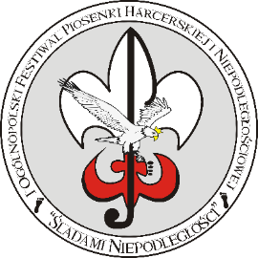
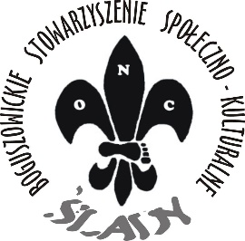
Application Card
„TRACKING INDEPENDENCE”
2nd Festival of Scout and Independence Song
(8 June 2019r. - Rybnik)

- Performer (band name or name and surname soloist)
………………………………………………………………………………………………………
- Name of organization
……………………………………………………………………………………………………….
- Information about carer
  - Name and Surname:……………………………………………………………………………
  - PESEL: …………………………………………………………………………………….
  - Adress of residence: ..…………………………………………………………………………………….
  - Phone number: .……………………………………………………………………..
  - E-mail: .………………..……………………………………………………………………
- List of attendess
L.p. | Name and Surname | Date of Birth | PESEL | Diner

- Category
……………………………………………………………………………………………………..
- Song
L.p. | Type of song | Time of execution | Author of words / Author of music
1. | Scout song or tourist song
2. | Independence song

- Short characteristics of performer (for announcer):

- Technical requirments (number of microphones, number of inputs for the guitar, number of chairs):

- Lyrics of the song:

- Accommodation : Yes/No (detailed information in number 601311402)

